SAM SHENDI

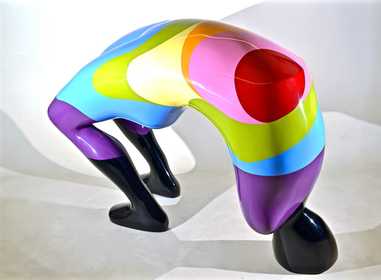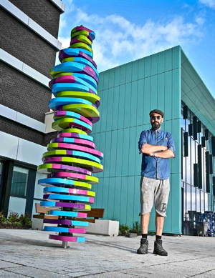
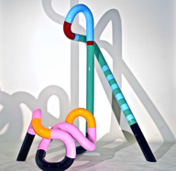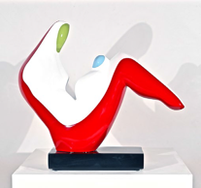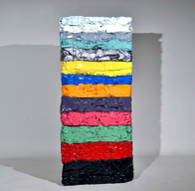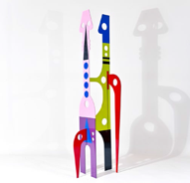

CV

Member of Royal Society of Sculptors
Member of the Society of Scottish Artists
Member of Visual Art Scotland

Education

University of Helwan, Zamalek, Cairo 1992 – 1997
BA (Hons) Monumental and Architectural Sculpture: 1st Class

Exhibitions

2023 Solo Exhibition, See My Voice, Zamalek Art Gallery, Cairo
2023 Forever is Now Exhibition, Giza, Cairo
2023 Summer Exhibition, Royal Academy of Arts, London
2022 Solo Exhibition, Identity, Zamalek Art Gallery, Cairo
2022 Group Exhibition, Visual Arts Scotland, Royal Scottish Academy, Edinburgh
2022 Group Exhibition, Graham Fine Art Gallery, Johannesburg
2021 Group Exhibition, The Contemporary Art Museum, Cairo
2021 Solo Exhibition, Hidden Visible, Zamalek Art Gallery, Cairo
2021 Group Exhibition, Sculptour Beukenhof museum, Belgium
2020 Solo Exhibition, Motherland, Zamalek Art Gallery, Cairo
2020 Group Exhibition, Cairo Salon 59, The Palace Of Art Museum, Cairo
2020 Group Exhibition, The Royal Sculptors Summer Exhibition, London
2020 Group Exhibition, Sculptour Beukenhof Museum, Belgium
2019 Group Exhibition, Visual Arts Scotland, Royal Scottish Academy, Edinburgh
2019 Group Exhibition, The Royal Scottish Academy Annual Exhibition, Edinburgh
2019 Group Exhibition, Art Catto Gallery, Algarve, Portugal
2019 Group Exhibition, Sculptour Beukenhof Museum, Belgium
2019 London Art Fair, AN INC Gallery, London
2018 Solo Exhibition, Start Art Fair, Saatchi Gallery, London
2018 Group Exhibition, William Benington Gallery, Sculpture Fulmer, London
2017 Solo Exhibition, Seasons, Graham Fine Art Gallery, Johannesburg
2016 Solo Exhibition, Mother and Child, The Civic, Barnsley
2015 Solo Exhibition, Body & Soul, Munich, Germany
2015 Solo Exhibition, Art at the Races, Baden-Baden, Germany
2014 Solo Exhibition, Cartwright Hall Museum &Art Gallery, Bradford
2014 Solo Exhibition, Venn Projects, Blackpool
2013 Solo Exhibition, The Royal British Society of Sculptors, London

Public Display

2022 MRC Laboratory of Molecular Biology, Cambridge
2022 Devonshire Square, London
2020 Exchange House, London
2019 99 Bishopsgate, London
2018 Aldgate Tower, London
2018 101 Barbirolli Square, Manchester
2018 Devonshire Square, London
2018 St. Botolph Building, London
2016 Berkeley Square House, London
2014 88 Wood Street Skyscraper, London
2014 Lister Park, Bradford

Public Commission

2022 The Royal Liverpool University, Liverpool.
2022 Saudi Lime, Riyadh, Saudi Arabia
2021 Aintree University Hospital, Liverpool
2019 The Cunard Ocean Liner Sculpture
2013 The Royal British Society of Sculptors, London
2011 Baptist Church, North Yorkshire
2011 Silsden Town Council, West Yorkshire

Awards
2020 W Gordon Smith & Mrs Jay Gordon Smith Award.
2019 Liverpool Plinth. Winner of the Public art award.
2013 FIRST@108 Public Art Award. The Royal Society of Sculptors

Film
2020 The Bay of Silence
2015 Avengers Age of Ultron, Marvel Studio

23 Fold Lane, Cowling, Yorkshire, BD22 0BG T: 07967 584532 E: samshendi@hotmail.com www.samshendi.co.uk

